**SVKM’s NMIMS**

**Mukesh Patel School of Technology Management and Engineering, Mumbai**

**Department of Electronics & Telecommunication**



**Programming for Problem Solving (Exp 1-1)**

|  |  |
| --- | --- |
| **Roll No: J001** | **Name: Adith Ramakrishna** |
| **Program: B. Tech Data Science (1st)** | **Batch: J1** |
| **Date of Experiment: 03/10/2022** | **Date of Submission: 03/10/2022** |

**Task 1:**

**Algorithm:**

**Step 1:** Start

**Step 2:** Initialize variable wallet to 500, Mprice to 50,

Mquant to 2, Tprice to 10, Tquant to 2.5, Cprice

to 35, Cquant to 1.5

**Step 3:** wallet=500-

(Mprice*Mquant+Tprice*Tquant+Cprice*Cquant)

**Step 4:** Display the cash to be returned by printing the

new value of wallet

**Step 5:** Stop

**Flowchart:**

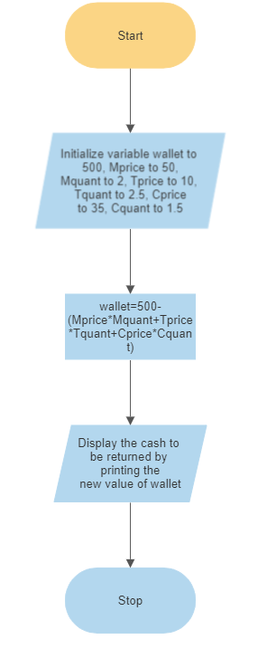

**Task 2:**

**Algorithm:**

**Step 1:** Start

**Step 2:** Take input for X after declaring it of int

Type

**Step 3:** If X%2 is equal to 0, display X as even,

else display as odd

**Step 4:** Stop

**Flowchart:**

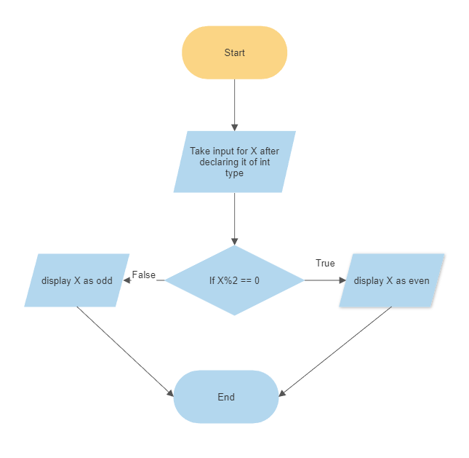

**Task 3:**

Variables used ch,l,b,r,base,h of double type

**Flowchart:**

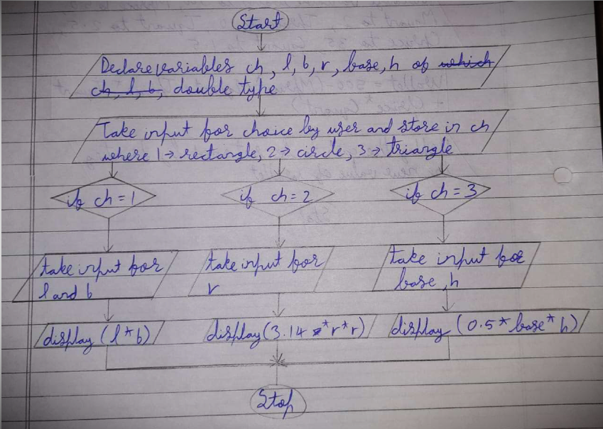

Dry run: for radius 6 units, area of circle=3.14*3.14*6=59.1576 sq units

**Task 4:**

**Flowchart:**

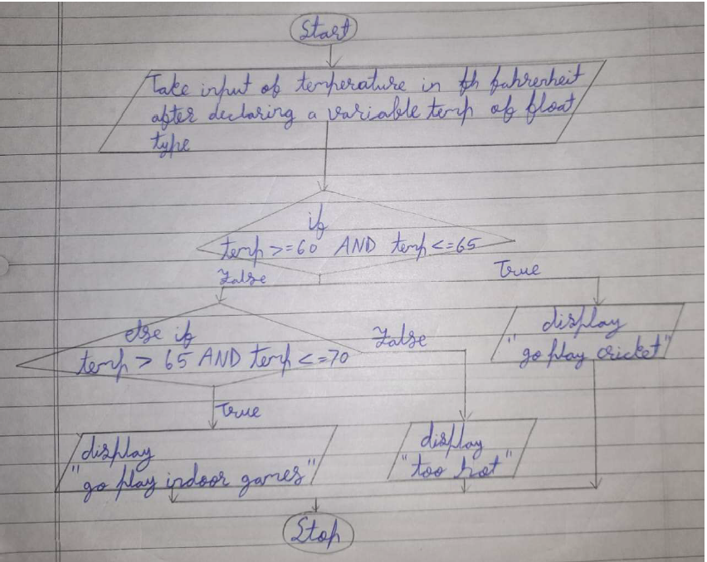

**Homework Questions:**

**1.**

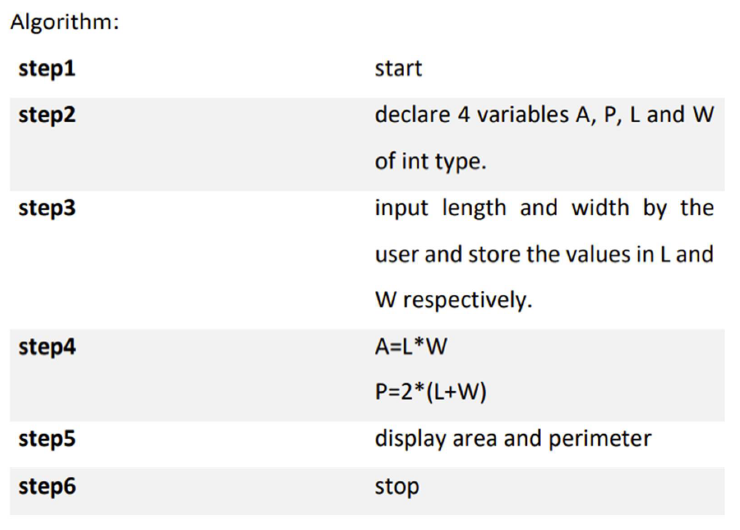

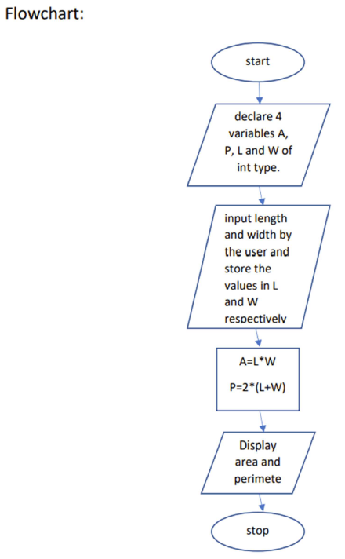

**2.**

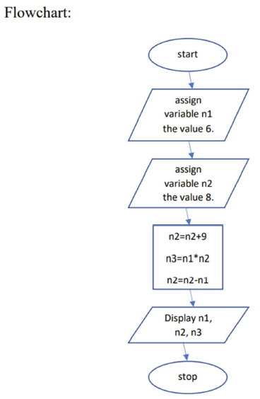

**3.**

